**OPTIMIZATION OF GEOMETRICAL CHARACTERSTICS OF BUILDING BY USING DIAGRID SYSTEM AGAINST LATERAL FORCES**

Vaishnavi Marodkar1, Prof. Priti Rana2

1(M.Tech Student, Structural and construction Engineering Department, Ballarpur Institute of Technology, Maharashtra, India)

2(Assistant Professor, Structural and construction Engineering Department, Ballarpur Institute of Technology, Maharashtra, India)

*Vaishnavim2307@gmail.com*

|  |
| --- |
| ***Abstract:****In this present era of population growth and scarcity of available land, engineers and architects are bound to construct high-rise buildings. Lateral loads are considered as most dominant factor in the construction of high-rise buildings. To improve the efficiency of high-rise buildings, new structural systems like diagrid and hexa-grid are introduced. A Diagrid structural system resists lateral load by presence of inclined columns in the periphery of the building. In this study, various diagrid models with different diagrid angles were analyzed through pushover analysis by using FEMA 356 & ATC 40 and the results were compared with a conventional frame building of same dimension. Pushover analysis is a good way of accessing the sequence of failure by indicating hinges. The method can be used where the structure needs to be fine-tuned or it needs to be retrofitted. In this study it was found that diagrid performs well against lateral forces in comparison to conventional frame building. The hinge results of test beam showed that the 1-story diagrid module gave around 70% lower values of moment at plastic stage in comparison to simple frame structure. The performance point of all the diagrids were also better than simple frame with around 70% plus values. The story displacement value for all the diagrid modules was efficient in relation to simple frame structure with almost 70% lower displacement values. This study suggests that the usage of diagrids in building helps in improving performance of tall structures and also helps in reducing the overall cost of the structure.*  ***Key Word****:* ***Diagrid structure, Plastic Hinge, Storey Displacement, Pushover Analysis.*** |

1. **Introduction**

### General

A diagrid structure is a type of architectural framework characterized by its diagonal grid pattern. It consists of diagonal members that form triangular shapes, providing both structural support and aesthetic appeal. Diagrid structures are commonly used in skyscrapers, bridges, and other large-scale constructions due to their strength, efficiency, and striking visual impact. Hearst Tower in New York City, which is designed by Norman Foster, uses 21% less steel than a standard design. The term "diagrid" is a portmanteau of "diagonal" and "grid," highlighting the primary feature of this structural system. Unlike traditional orthogonal grids, which utilize horizontal and vertical members, diagrids employ diagonal members that intersect to form a network of triangles. This arrangement enhances the structure's stiffness and load-bearing capacity while reducing the need for internal columns or walls. One of the key advantages of diagrid structures is their ability to distribute loads efficiently. The diagonal members work in tension and compression to transfer forces to the foundation, allowing for greater stability and structural resilience. Additionally, the absence of conventional vertical columns can create open, column-free interior spaces, offering flexibility in design and maximizing usable floor area. These buildings showcase the aesthetic versatility and structural integrity of diagrid systems, contributing to their widespread use in contemporary architecture.

### 1.2 Diagrid Structure

The diagrid structural system is often outlined as diagonal members shaped as a framework created by the intersection of various materials like metals, concrete or wood beams that is employed within the construction of buildings and roofs. Diagrid structures of the steel members result in most economical case each in terms of strength and stiffness. However today a widespread application of diagrid is employed within the massive span and high rise buildings.

Module Geometry of Diagrid Structural System:

1. **Diagrid Best Angle**

The diagonal member of the diagrid carries shear force and moment. The best angle for putting the diagonals relies on building height. The best angle of the columns for optimum bending rigidity within the traditional building is ninety degrees and for the diagonals for shear rigidity is thirty-five degrees. It’s assumed that the best angle of the diagrid falls in between these values. Typically adopted angle is 60-70 degrees.

1. **Diagrid Module Dimensions**

The module dimensions depends on majorly two things:

**Height:** the peak of the diagrid depends on the number of floors stacked in one module of the diagrid. The common range of floors stacked for modules of the diagrids square measure two to six.

**Base of the module:** the bottom on which the diagrid is created typically depends on the peak and also the best angle of the diagrid.

Types of Diagrid Structural System and Materials of Construction the materials used in diagrid depends upon several factors:

1. Availability of fabric
2. Erection time
3. Flexibility
4. Durability
5. Unit weight of the fabric
6. Labor cost
7. Lead time

.

The materials used in the construction of diagrid structure are:

1. Steel Diagrid Structural System

The most commonlly and popularly used material within the construction of diagrid is steel. The sections normally used square measure rectangular HSS, rounded HSS and wide flanges. The

burden and size of the sections depends on the required resistance of the the high bending masses. They will be quickly erected and also the price of labor for the installation is low.

1. Concrete Diagrid Structural System

The most commonly used diagrid material is concrete. The concrete structures are versatile and it additionally protects from fireplace damages.

1. Timber Diagrid Structural System

The less used material within the construction of diagrids is timber. This material has additional disadvantages. The sole advantage of this material is that the section of timber square measure is simply obtainable in any form and size. The installation price is low. The main disadvantage is that timber has lesser material strength. Sturdiness and weathering of timber are the main problems that produce the disadvantages of timber as a diagrid construction material.

Advantages of Diagrids:

* Diagrid structures are inherently strong and stable due to their triangulated geometry, which efficiently distributes loads and resists lateral forces such as wind and seismic loads. The diagonal members work in tension and compression, providing structural integrity and minimizing deflections.
* Diagrid structures optimize the use of materials by eliminating the need for conventional vertical columns or shear walls. The diagonal members form a continuous network of triangles, which maximizes structural efficiency and minimizes material usage while maintaining structural performance.
* Diagrid structures are often prefabricated off-site or assembled using modular components, leading to faster construction times and reduced labor costs. The repetitive nature of the diagonal grid pattern allows for efficient fabrication and erection processes, streamlining the construction workflow.

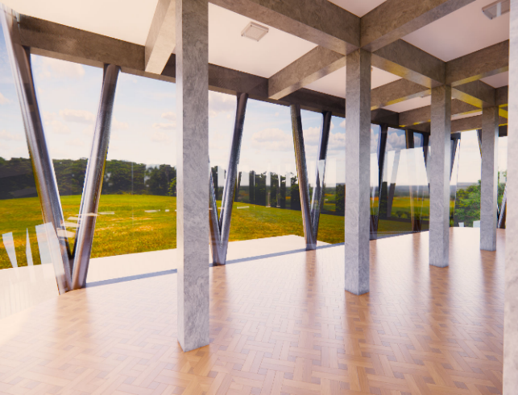

**Figure** **1.1:** Diagrid Model, Internal Render-1 **Figure1.2:** Daigrid Model , External Render-2

### Objectives

* The main objective of the study is to find the performance of diagrid structure with varying angles of 82°, 78°, 67° & 50° in comparison to a simple frame building for the seismic characteristics for the Pune region of Maharashtra.
* To determine the formation of hinges in the diagrid structure and to plot M-Ɵ curve to establish a comparison between simple frame structure and a diagrid structure regarding the performance in plastic zone of lateral loading.
* To determine the story displacement of diagrid node points, so that an efficient comment can be made on whether the diagrids are efficient for tall structures in comparison to simple frame structures.

1. **Methodology**
   1. Methodology for comparison of seismic resistance of diagrid structure with different soil profiles can be studied. A detailed capacity spectrum can be generated with the help of FEMA-356 and other standard codes. The failure of members can be predicted with the help of simulation software such as Etabs/Sap2000/StaadPro. Analysis with varying angles of diagrid and soil parameters can be studied and its relevance in future planning of high-rise building can be accessed.

*As* *per* *IS* *1893:2002*

* + - Seismic Zone : Zone IV
    - Seismic Factor : 0.24
    - Seismic Analysis Method (For initial analysis) : Equivalent static method
    - Soil Type : Type I (Rocky Hard Soil)
    - Importance Factor : 1
    - Response Reduction Factor : R = 5 (SMRF)
    - Load Combinations :

**Table** **1**: **Load Combinations as per IS 456:2000, IS 1893-2002**

|  |  |
| --- | --- |
| **Factors** **for** **Serviceability** | **Factors** **for** **Collapse** |
| DL+LL | 1.5(DL+LL) |
| DL±EQX | 1.5(DL±EQX) |
| DL±EQY | 1.5(DL±EQY) |
| DL+0.8LL±EQX | 1.2(DL+LL±EQX) |
| DL+0.8LL±EQY | 1.2(DL+LL±EQY) |

*As* *per* *IS* *875:1987* *(Part-1* *&* *Part-2)*

Loads for building taken as:

* + - * Dead Load on Slab = 2.5 kN/m2
      * Live Load on Slab = 3 kN/m2

*As* *per* *FEMA* *356*

Pushover Analysis with Displacement Coefficient Method was done.

*As* *per* *ATC* *40*

CSM (Capacity Spectrum Method) can be carried out. Performance points can be accessed.

### Methodology Of Analysing Structure Through FEMA356/ATC 40

* Load Cases of Pushover nonlinear static will be defined as PA-X with acceleration in X- Direction and PA-Y in Y-direction.
* Mass sources with 100% Dead load & 25% Live load are considered as per IS 1893 is considered
* Node 607 (topmost at (18, 0)) was pushed up to 300 mm of displacement
* DCM & CSM were used as stated in FEMA-356/440, ATC 40.
* Hinges were fixed at 10% distances from either ends for both the beams & columns as per FEMA 356.
* Capacity spectrum can be plotted according to ATC 40 & Displacement coefficient method can be accessed with FEMA 356.

**Member** **Sizes** **taken:**

* + - 1. Beam Size/ Section: 300x500 mm
      2. Column Size/ Section: 500x500 mm
      3. Slab : 150 mm

###### The followingtypesofdiagridmodelsweremodelledinSAP2000andwereanalyzedonebyonethroughpushoveranalysis.

**Table** **2.1**: **Various diagrid modules with angle**

|  |  |
| --- | --- |
| **Module** | **Diagrid** **Angle** |
| 6-Story Module | 82 degrees |
| 4-Story Module | 78 degrees |
| 2-Story Module | 67 degrees |
| 1-Story Module | 50 degrees |
| Frame Building | - |

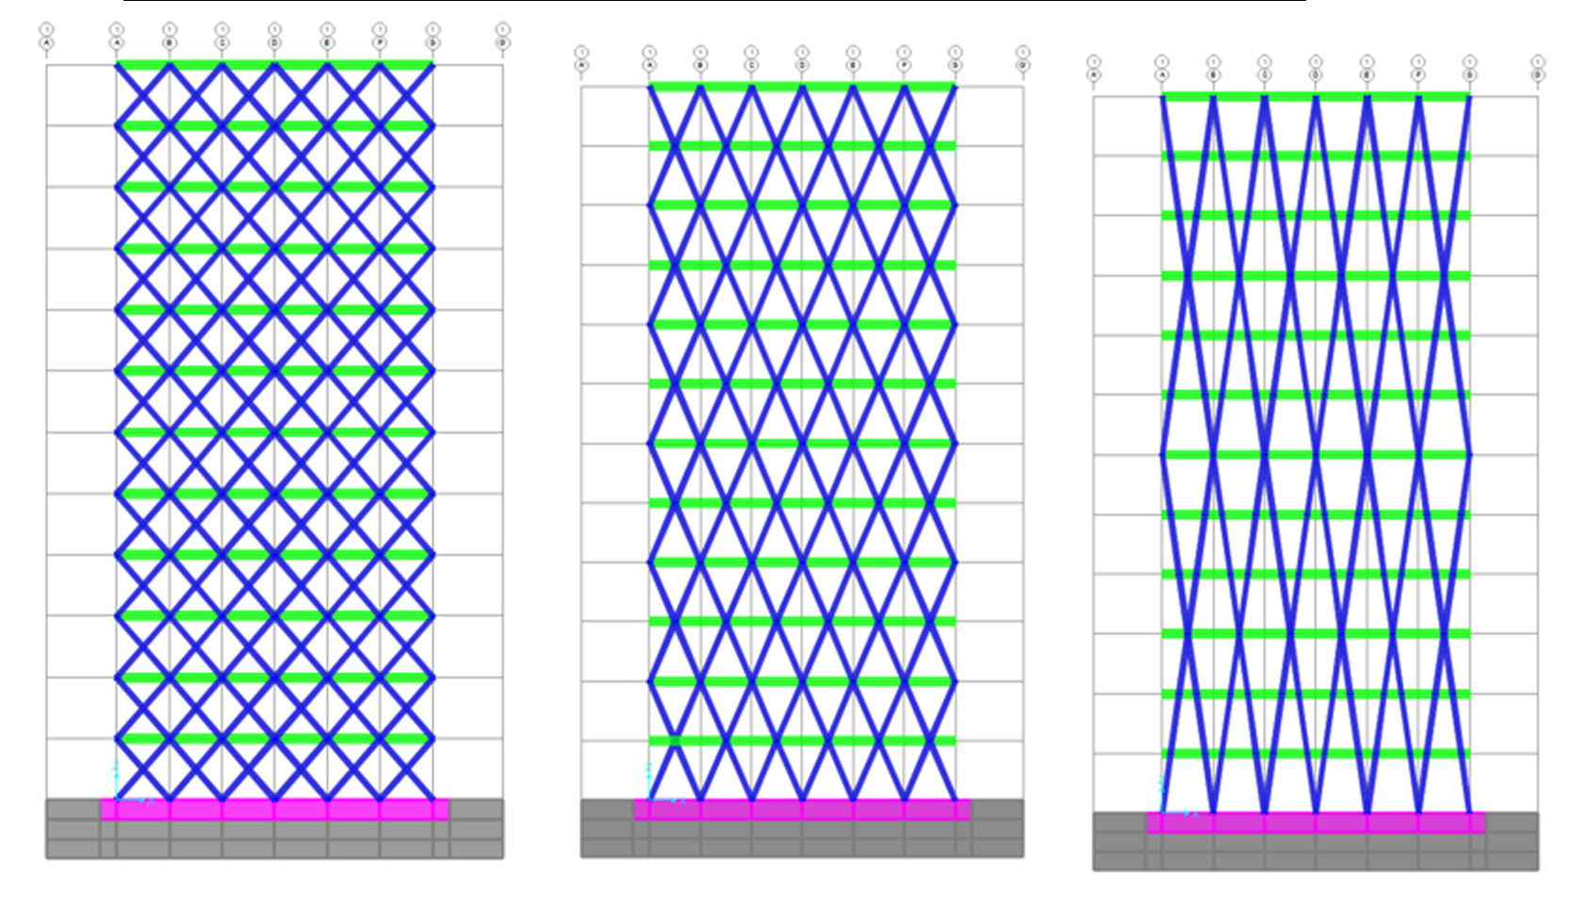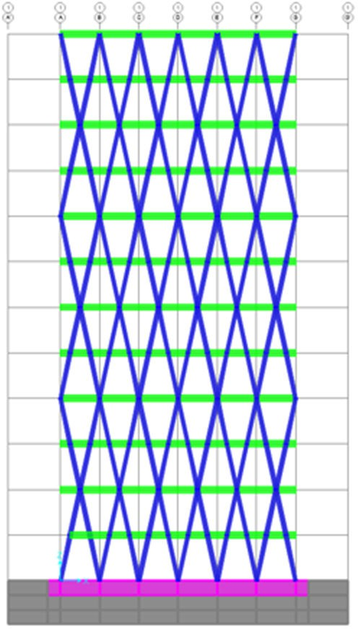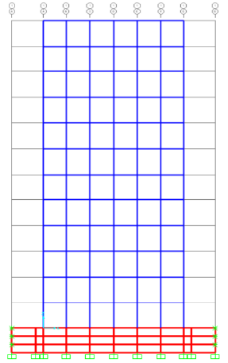

1-storey 50֯ module 2-storey 67֯ module 4-storey 78֯ module 6-storey 80֯ module Frame Building

**Figure 2.2: All the diagrid modules and frame building modelled in Sap 2000**

## **Results & Discussions**

### Plastic Hinge Formation Results:

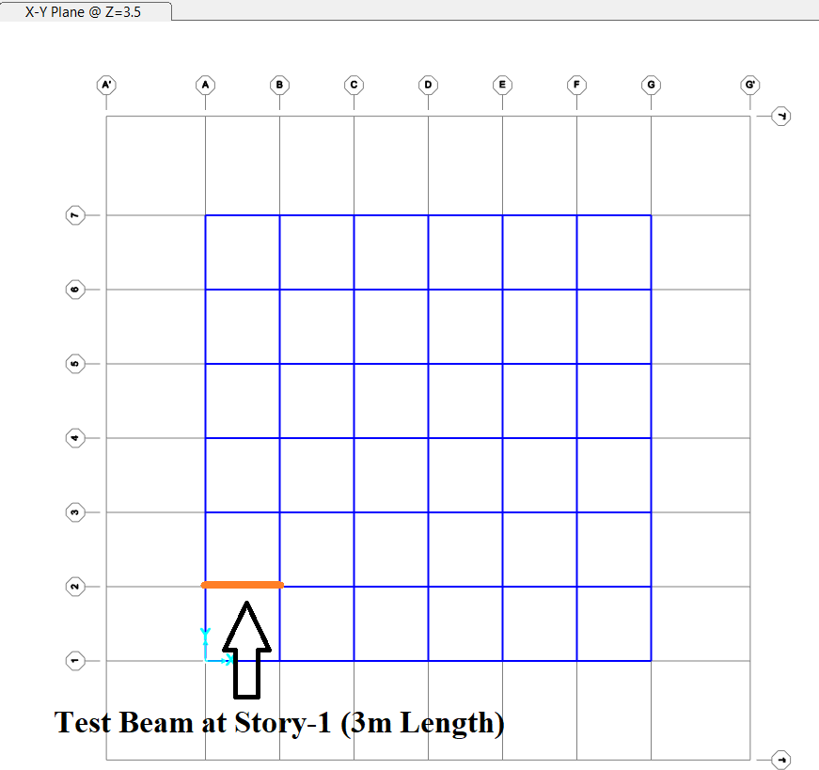For accessing the plastic hinge formation behavior for various angles of diagrid and simple frame structure each of 12-Story, a test beam is selected at ground floor having initial coordinates at (0, 3) and final coordinates at (3, 3) having a total span length of 3 meters. The in-model label of this test beam is 324 in all models. The size as stated earlier of this beam is 300X500 mm in all the models.

**Figure** **3.1:** **Test Beam for all the diagrid model and framed buildings**

M-Ɵ Curve of the test beam 324 is being evaluated hereby for the Pushover case of Pa-X loaded at the extreme step of analysis with its state also.

First All the Hinge results for every module has been written here individually and at last they are compared all together in a table. The analysis figures and all the tables has been attached hereby to get a clear understanding of the moment rotation curve. Before accessing the hinge results we need to know the Hinge formation cycle/steps (states) as per Pushover analysis, which is shown below:

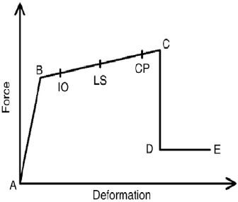

**Figure 3.2: Force v/s Deformation for Hinge formation.**

Where-

Immediate occupancy is meant by IO

Life safety is meant by LS

Collapse prevention is meant by CP. A, B, C, D, E are hinge state points.

##### HingeResultsComparisonforAllModels:

**Table** **4.1:** **Comparing results of hinges**

|  |  |  |  |  |  |
| --- | --- | --- | --- | --- | --- |
| **Module** | **Relative** **Distance** | **Moment** **(kN-m)** | **Rotation** **(radians)** | **Hinge** **State** | **Hinge** **Status** |
| 6-Story 82◦ | 0.1 | -57.0909 | 0.00278 | B <= C | A <= IO |
| 0.9 | 87.6706 | 0.00279 | B <= C | A <= IO |
| 4-Story 78◦ | 0.1 | -56.9059 | 0.00146 | B <= C | A <= IO |
| 0.9 | 87.3581 | 0.001913 | B <= C | A <= IO |
| 2-Story 67◦ | 0.1 | -30.776 | 0 | A <= B | A <= IO |
| 0.9 | 81.9506 | 0 | A <= B | A <= IO |
| 1-Story 50◦ | 0.1 | -17.3625 | 0 | A <= B | A <= IO |
| 0.9 | 17.1365 | 0 | A <= B | A <= IO |
| Frame Building | 0.1 | -72.1565 | 0.005642 | B <= C | A <= IO |
| 0.9 | 87.3692 | 0.004405 | B <= C | A <= IO |

From Above M-Ɵ Values we can see that Test beam of Conventional Frame building (in red color) results in formation of hinges with a maximum value of Moment and Rotation, also the hinges are in A<=B. As compared to 1 Story module (50-degree diagrid) (In green color) the moments are almost 70% lower and rotation is zero as the test beam has not entered the plastic stage.

The other diagrid module can be checked also in the same way and it can be concluded that by increasing diagrid angle the plastic moment increases with increase in rotation also.

From above discussion it can be concluded that 1-Story diagrid (Diagrid angle of 50 degrees) module can result in better performance for all the structural components and also there’ll be less consumption of steel (at least 20%) as peripheral columns are not present.

### Moment Capacity Curves for All Module:

In this section of result and discussion, the capacity curve and demand curve with the performance point according to ATC-40 capacity spectrum has been stated for all the diagrid modules and the result has been shown below:

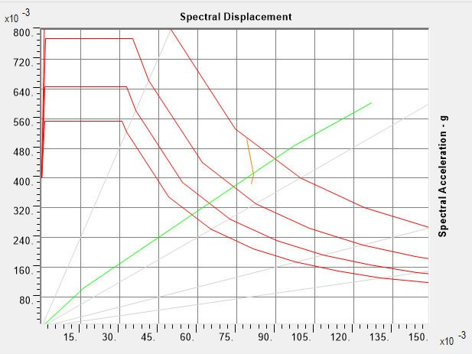

**Figure 3.5: Pushover Curve according to ATC-40 Capacity Spectrum**

##### ComparisonofPerformancePoint

**Table** **3.2:** **Comparing results of performance points**

|  |  |
| --- | --- |
| **Module** | **Performance** **Point** **(Kn)** |
| 6-Story 82◦ | 16072.393 |
| 4-Story 78◦ | 19185.795 |
| 2-Story 67◦ | 26630.88 |
| 1-Story 50◦ | 27590 |
| Frame Building | 9417.21 |

The Performance Point, which represents the state of maximum inelastic capacity of the structure, is found through the cross point of the Capacity Spectrum and Demand Spectrum

From above data it can be concluded that for diagrid with 1-story module the performance point is highest at 27590 kN and it is lowest for conventional frame building at 9417.21 kN

### Story Drift Values for All Modules

**Figure 3.6: Test Points for displacement value**

Joint displacement values for all the stories has been plotted on a graph with Base Shear in X-direction on Horizontal axis and Joint displacements on Y-axis. All the results correspond to Pa-X pushover load case. The test nodes for displacements are taken as Joint 367, 415, 463, 511, 559, 607.

**Table 3.3: Comparing results of joint displacements for 6-Story 82◦ Module**

|  |  |  |  |  |  |  |
| --- | --- | --- | --- | --- | --- | --- |
|  | **Displacement** **Values** **in** **mm** | | | | | |
| **Max.** **Base** **Shear**  **(kN)** | **Joint**  **367** | **Joint**  **415** | **Joint**  **463** | **Joint**  **511** | **Joint**  **559** | **Joint**  **607** |
|  | **Story-2** | **Story-4** | **Story-6** | **Story-8** | **Story-10** | **Story-12** |
| 22702.467 | 52.09 | 87.43 | 116.18 | 138.11 | 152.5 | 160.43 |

**Table 3.4: Comparing results of joint displacements for 4-Story 78◦ Module**

|  |  |  |  |  |  |  |
| --- | --- | --- | --- | --- | --- | --- |
|  | **Displacement** **Values** **in** **mm** | | | | | |
| **Max.** **Base** **Shear**  **(kN)** | **Joint**  **367** | **Joint**  **415** | **Joint**  **463** | **Joint**  **11** | **Joint**  **559** | **Joint**  **607** |
|  | **Story-2** | **Story-4** | **Story-6** | **Story-8** | **Story-10** | **Story-12** |
| 29843.567 | 41.08 | 74.86 | 103.06 | 124.81 | 140.58 | 150.46 |

**Table 3.5: Comparing results of joint displacements for 2-Story 67◦ Module**

|  |  |  |  |  |  |  |
| --- | --- | --- | --- | --- | --- | --- |
|  | **Displacement** **Values** **in** **mm** | | | | | |
| **Max.** **Base** **Shear**  **(KN)** | **Joint**  **367** | **Joint**  **415** | **Joint**  **463** | **Joint**  **511** | **Joint**  **559** | **Joint**  **607** |
|  | **Story-2** | **Story-4** | **Story-6** | **Story-8** | **Story-10** | **Story-12** |
| 25706.006 | 14.84 | 28.89 | 42.07 | 53.65 | 63.26 | 70.82 |

**Table 3.6: Comparing results of joint displacements for 1-Story 50◦ Module**

|  |  |  |  |  |  |  |
| --- | --- | --- | --- | --- | --- | --- |
|  | **Displacement** **Values** **in** **mm** | | | | | |
| **Max.** **Base** **Shear**  **(kN)** | **Joint**  **367** | **Joint**  **415** | **Joint**  **463** | **Joint**  **511** | **Joint**  **559** | **Joint**  **607** |
|  | **Story-2** | **Story-4** | **Story-6** | **Story-8** | **Story-10** | **Story-12** |
| 18552.4466 | 6.75 | 16.64 | 23.09 | 31.35 | 38.98 | 45.8 |

**Table 3.7: Comparing results of joint displacements for Frame Building**

|  |  |  |  |  |  |  |
| --- | --- | --- | --- | --- | --- | --- |
|  | **Displacement** **Values** **in** **mm** | | | | | |
| **Max.** **Base** **Shear**  **(kN)** | **Joint**  **367** | **Joint**  **415** | **Joint**  **463** | **Joint**  **511** | **Joint**  **559** | **Joint**  **607** |
|  | **Story-2** | **Story-4** | **Story-6** | **Story-8** | **Story-10** | **Story-12** |
| 10655.46 | 78.82 | 116.19 | 138.82 | 150.73 | 157.14 | 160.68 |

From above tables and values it can be concluded that 1-Story Module of diagrid with 50 degrees is showing very much less lateral displacements (almost 150% lower) in comparison to others, the highest point has displaced only 45 mm. Thus it can be concluded that the 1-Story diagrid module can be regarded as the most economical diagrid angles system in comparison to any other configuration in terms of Hinge formation, Performance behavior and joint displacements.

## **Conclusions**

It was found that various parameters influence the lateral resistance towards deflection. Parameters like targeted displacements and the complexity of the structure can cause different results.

Diagrid structures can be used with varying angles to increase the stiffness of the building towards the deflections. The failure sequence can be easily accessed and prediction of member failure can be accessed.

The comparative study has been successfully executed for different diagrid structures using SAP 2000 software to find the stiffness and flexibility of the high-raised structures and also for an asymmetrical structure through simple framework. The lateral load resisting system is better at resisting the gravity loads than the structural system when the structure height gets increased. The configuration and efficiency of the diagrid system has reduced the number of structural elements. The SAP2000 software is used to design and analyze the results such as axial, shear and bending moment. The possibility of failure is much lesser for diagrid structure when compared to the conventional structure by heavy vibrations during an earthquake.

The diagrid structures are becoming popular due to their advantages. Many projects have started to adapt diagrids to reduce cost, versatility and aesthetic appeal of diagrids. However, there is limited academic research on geometry of diagrids and variable angle diagrids which can help many construction projects. Also, the variable angle diagrids can be more efficient and can help reducing cost more than diagrids with constant angle of inclination. This study looks into the different configurations of the variable angle diagrid system and compares the results based on the efficiency factor calculated for each configuration of the models selected for the study. Selecting the suitable configuration of the variable angle diagrid system can help in further reducing cost and material used for construction. The 1-Story module with 50 degrees is best from structural point of view but one can choose any other form as all diagrids are performing way better in terms of plastic stage and joint displacements in relation to a bare conventional frame.

Diagrids can result in less consumption of steel (almost 20%) than conventional frame building as Gdiagrids has lesser number of columns, in our study the bare frame had 588 columns and diagrid had 300 only, and that’s around 50% less.

## **References**

1. Sivapalan Gajan, Prishati Raychowdhury, Tara C. Hutchinson, *Application* *and* *Validation* *of* *Practical* *Tools* *for* *Nonlinear* *Soil-Foundation* *Interaction* *Analysis.* *Volume:* *26* *issue:* *1,* *page(s):* *111-129,* *Earthquake* *Spectra.*
2. George Gazetas and Marios Apostolou, *Nonlinear* *Soil–Structure* *Interaction:* *Foundation* *Uplifting* *and* *Soil* *Yielding,* *Proceedings* *Third* *UJNR* *Workshop* *on* *Soil-* *Structure* *Interaction,* *March* *29-30,* *2004,* *Menlo* *Park,* *California,* *USA.*
3. Dabbaghchian, Iman; Mirghaderi, Seyed Rasoul; Sayadi, Sina (2020). *Comparison* *of* *seismic* *behavior* *of* *the* *eccentric* *and* *conventional* *diagrid* *systems.* *The* *Structural* *Design* *of* *Tall* *and* *Special* *Buildings.*
4. Mr. Anirudha, Dr. R A Dubal, *Nonlinear* *Seismic* *Analysis* *Of* *Normal* *Structure* *With* *Diagrid* *Structure* *Using* *Etabs,* *Volume* *6,* *Issue* *7,* *July* *2021,* *Open* *Access* *International* *Journal* *of* *Science* *&* *Engineering.*
5. Valentina Tomeia, Maura Imbimbob, Elena Melec. *Optimization* *of* *structural* *patterns* *for* *tall* *buildings:* *The* *case* *of* *diagrid,* *Engineering* *Structures* *171* *(2018)* *280–297.*
6. Sepideh Korsavi and Mohammad Reza Maqhareh, *The* *Evolutionary* *Process* *of* *Diagrid* *Structure* *Towards* *Architectural,* *Structural* *and* *Sustainability* *Concepts:* *Reviewing* *Case* *Studies.*
7. Kiran Kamath, Sachin Hirannaiah, Jose Camilo Karl Barbosa Noronha, Engineering and Material Sciences, <http://dx.doi.org/10.1016/j.pisc.2016.04.004>.
8. Rahul Leslie, Assistant Director, Buildings Design, DRIQ Board, Kerala PWD, Trivandrum, *The* *Pushover* *Analysis,* *explained* *in* *its* *Simplicity*.
9. Engineering Training and Testing Laboratory, accredited laboratory by NABL, National Accreditation Board for Testing and Calibration Laboratories (Department of Science and Technology Govt. of India) located in Vaishalinagar, Jaipur, and Rajasthan.
10. IS 1893 (Part 1)–2002, “*Indian* *Standard* *Criteria* *for* *Earthquake* *Resistant* *Design* *of* *Structures,* *Part* *1:* *General* *Provision* *and* *Buildings*”, Bureau of Indian Standards, New Delhi.
11. FEMA 356 (2000) “*Prestandard* *and* *Commentary* *for* *the* *Seismic* *Rehabilitation* *of* *Buildings*”, Federal Emergency Management Agency, Washington, DC, USA.
12. ATC-40 (1996) “*Seismic* *Analysis* *and* *Retrofit* *of* *Concrete* *Buildings*”, vol. I, Applied Technology Council, Redwood City, CA, USA.
13. FEMA-440 (2205) “*Improvement* *of* *Nonlinear* *static* *seismic* *analysis* *procedures*”, Federal Emergency Management Agency, Washington, DC, U.S.A.
14. EN 1998-1:2003, “*Eurocode* *8:* *Design* *of* *structures* *for* *earthquake* *resistance* *-* *Part* *1:* *General* *rules,* *seismic* *actions* *and* *rules* *for* *buildings*”, European Committee for Standardization, Management Centre: rue de Stassart, 36 B-1050 Brussels.
15. Mehmet Inel & Hayri Baytan Ozmen, "*Effects* *of* *plastic* *hinge* *properties* *in* *nonlinear* *analysis* *of* *reinforced* *concrete* *buildings*", Engineering Structures 28 (2006) pg. 1494– 1502 ([http://www.elsevier.com/locate/engstruct).](http://www.elsevier.com/locate/engstruct))
16. Etabs. “*Integrated* *software* *for* *structural* *analysis* *and* *design*”, Computers and Structures Inc., Berkeley, CA, USA.
17. SAP 2000, Computers and Structures Inc., Berkeley, CA, USA
18. Trupti A. Kinjawadekar, *Comparative* *Study* *of* *Seismic* *Characteristics* *of* *Diagrid* *Structural* *Systems* *in* *High* *Rise* *Construction.* International Journal of Civil Engineering and Technology (IJCIET) Volume 9, Issue 6, June 2018, pp. 315–323
19. G. Lecidogna, *Influence* *of* *the* *geometrical* *shape* *on* *the* *structural* *behavior* *of* *diagrid* *tall* *buildings* *under* *lateral* *and* *torque* *actions.* <https://doi.org/10.1016/j.dibe.2020.100009>.
20. Sivapalan Gajan, *Application* *and* *Validation* *of* *Practical* *Tools* *for* *Nonlinear* *Soil-* *Foundation* *Interaction* *Analysis*. Earthquake Spectra, Volume 26, No. 1, Pages 111- 129, February 2010.
21. Neha Tirkey, *Analysis* *on* *the* *diagrid* *structure* *with* *the* *conventional* *building* *frame* *using* *ETABS*. https://doi.org/10.1016/j.matpr.2019.08.107.
22. G. Lacidogna, *Influence* *of* *the* *geometrical* *shape* *on* *the* *structural* *behavior* *of* *diagrid* *tall* *buildings* *under* *lateral* *and* *torque* *actions.* *https://doi.org/10.1016/j.dibe.2020.100009.*
23. Sindhu Nachiar, *A* *Comparative* *Study* *on* *Seismic* *Analysis* *of* *Diagrid* *and* *Hexagrid* *Structural* *Systems.* April 2021, IOP Conference Series Materials Science and Engineering 1130(1):012006. DOI:10.1088/1757-899X/1130/1/012006
24. Kamil Ashraf Bhat, *Analyzing* *different* *configurations* *of* *variable* *angle* *diagrid* *structures*. <https://doi.org/10.1016/j.matpr.2020.11.372>.
25. sMahdi Heshmatia, *Seismic* *performance* *assessment* *of* *tubular* *diagrid* *structures* *with* *varying* *angles* *in* *tall* *steel* *buildings*. https://doi.org/10.1016/j.istruc.2020.02.030.